Tab 1
April 4th, 2025

Hussein Abdullah,
Professor
School of Engineering
University of Guelph

Subject: Final Report on an Advanced Drone Tracking Camera System

Dear Prof. Abdullah,

We are pleased to submit our final report for the development of an advanced drone tracking camera system. This report outlines our progress in designing a reliable, accurate, and autonomous tracking system that addresses the problem description, final design solution and defense, and the risks and uncertainties.

The purpose of this report is to provide you with a thorough and comprehensive overview of our project’s final status and achievements. We are eager to receive your feedback and hope that our product meets your expectations.

We appreciate your unwavering support throughout the course of this project and look forward to any future collaborations.

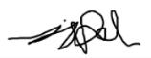
Yours’ sincerely,
Jake Lamoureux
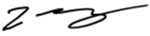
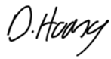
Laura Cao
Dominik Hoang
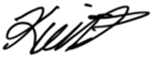
Kevin Pham

Advanced Drone Tracking Camera System

Prepared For
Professor Hussein Abdullah

Prepared By
Jake Lamoureux (0977310)
Laura Cao (1139598)
Dominik Hoang (1133423)
Kevin Pham (1124144)

April 4th, 2025
Guelph, Ontario
In signing this report, I certify that I have been an active member of the team and provided approximately equal contribution to the work. I take shared credit and responsibility for the content of this report. I understand that taking credit for work that is not my own is a form of academic misconduct and will be treated as such.

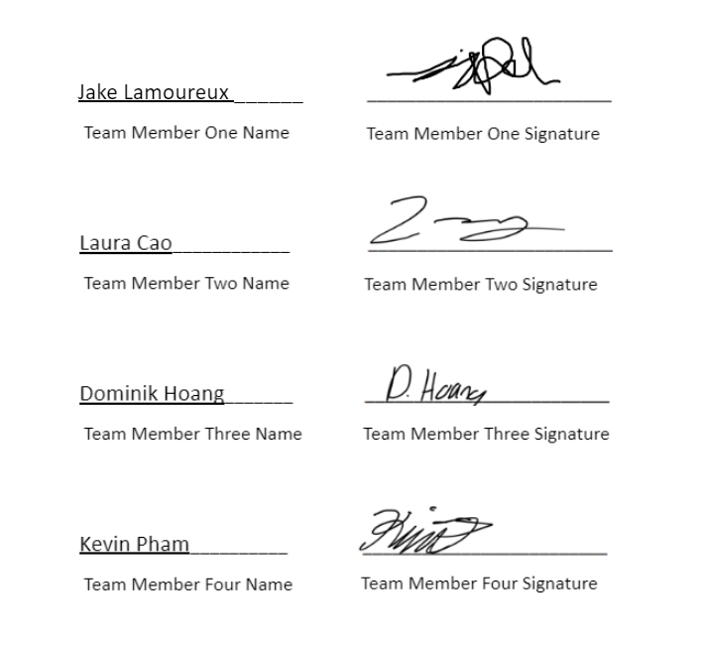

April 4th, 2025
Date

Executive Summary
The need for a reliable and efficient real-time drone tracking system comes from the increasing use of drones in various industries, including surveillance and agriculture. Current tracking systems often struggle with maintaining accuracy and stability, particularly in dynamic environments where fast-moving drones and environmental factors such as wind or low light can interfere with tracking performance. The challenge is to create a system that minimizes latency, improves accuracy, and ensures reliable performance under diverse conditions, while remaining cost-effective and scalable for broad usage.
The designed solution integrates a 360-degree rotating camera on a gimbal, controlled by servo motors and powered by a 460W power supply. The system utilizes Arduino Unos to process the video feed in real-time, using YOLOv8-based object detection to identify and track the drone, automatically adjusting the camera’s position to keep the drone in focus. This modular design is easily scalable and can be integrated into existing setups, ensuring flexibility and future-proofing for evolving drone technologies. The system has been designed to meet necessary safety, regulatory, and privacy standards.
The design addresses key user requirements such as minimizing latency, maximizing accuracy, and ensuring stability in dynamic environments. Preliminary testing demonstrates that the system outperforms previous models by providing stable detection and faster response times. The design considers user feedback, ensuring intuitive controls and seamless integration with existing drone technologies. Safety considerations were essential, with a stationary mount reducing risks and servo motors programmed for smooth, controlled movements. The system also complies with aviation regulations and has been tested under various real-world conditions to validate its reliability.
The system's performance is based on several assumptions, such as optimal operation in controlled environments and stable communication with drones within a specified range. However, factors like adverse weather, electromagnetic interference, and environmental conditions could affect tracking accuracy. Limitations include the system’s dependence on servo motors for mechanical adjustments, which can affect speed and precision. The power supply is also external, making it vulnerable to disruptions. Risks such as calibration errors, signal loss, and mechanical malfunctions may impact reliability. Opportunities for improvement include reducing hardware footprint, enhancing object detection algorithms, and adding redundancies to communication and power systems to increase reliability.
In conclusion, the real-time drone tracking system provides a reliable, scalable solution for drone tracking in dynamic environments, offering improved stability and accuracy over existing models. To enhance its market potential, future work should focus on improving portability, reducing cost, and making the setup process easier for non-technical users. Expanding compatibility with various drone models and improving performance in challenging environmental conditions will broaden its applications. Additionally, integrating advanced object detection algorithms and adding system redundancies could further enhance the system's reliability and efficiency.

Acknowledgements

We wish to express our profound gratitude to everyone who has made this project possible. Our deepest thanks are extended to Professor Abdullah, our project supervisor, for his invaluable suggestions and encouragement that have been instrumental in guiding us through the project, particularly in the preparation of this report.

Our appreciation is also extended to the University of Guelph for the support and resources provided. We would like to express our sincere thanks to the staff and faculty, whose permission to utilize necessary equipment and materials was important to the successful completion of our tasks.

We also wish to extend our heartfelt thanks to our families and friends for their understanding and support. Without the assistance of those mentioned above, we would have encountered numerous difficulties during the execution of this project.

Yours’ sincerely,

Jacob Lamoureux

Laura Cao

Dominik Hoang

Kevin Pham

Table of Contents
Executive Summary iii
Acknowledgements v
Table of Contents vi
List of Tables vii
List of Figures vii
1. Problem Definition 1
a. Problem Description 1
b. Background Information and Literature Review 1
c. Scope of Project 2
d. Constraints and Criteria 3
2. Design Solution 5
a. Design Process 5
b. Design Solution 6
c. Detailed Final Design 7
3. Design Defense 13
a. Function 13
b. Safety 13
c. Economic 13
d. Environmental Impact 14
e. Social Impact 14
4. Risks and Uncertainties 14
a. Assumptions 14
b. Limitations 15
c. Sources of Error 15
d. Potential Risks 15
e. Opportunities for Improvement 16
5. Conclusion and Recommendations 16
5. References 18
6. Appendices 19
Appendix A - Response to Feedback 19
Appendix B - Decision Matrices and Sensitivity Analysis 20
Appendix C - Calculations/Modeling 22
Appendix D - Project Management - Time Spent and Cost of Design 24
Appendix E - Additional Information 27

List of Tables
Table 1: Constraints with descriptions. 3
Table 2: Criteria with descriptions. 4
Table 3: Assumptions with descriptions. 4
Table 4: Bill of materials of the final design. 11
Table 5: Sensitivity Analysis. Criteria range: 5-Excellent 4-Very Good 3-Good 2-Satisfactory 1-Poor 20
Table 6: Decision Matrix. Criteria range: 5-Excellent 4-Very Good 3-Good 2-Satisfactory 1-Poor 21

List of Figures
Figure 1: Final design of the Advanced Drone Tracking Camera System. 8
Figure 2: Top-down view of the final system. 9
Figure 3: Resulting frame from the tracking systems display feed. 9
Figure 4: Schematic diagram of the Arduino Stepper Motor system. 10
Figure 5: SOLIDWORKS model of the camera bracket. 22

Problem Definition

Problem Description
With the increasing use of drones in sectors like security, surveillance, delivery, construction, agriculture, and entertainment, the need for reliable, accurate, and autonomous tracking systems is critical. Drones, often operating in dynamic and unpredictable environments, require tracking systems that support security monitoring, threat detection, navigation, and data acquisition [1]. However, current tracking solutions often suffer from limitations in real-time processing, environmental adaptability, and safety considerations. The problem lies in developing an advanced tracking camera system that can reliably track drones across diverse environments, enhancing operational safety, efficiency, and accuracy.
The lack of an advanced drone tracking system can lead to problems in real-time processing, environmental impact, and public safety. Socially, drones operating in public spaces can create privacy concerns and safety risks for civilians. An advanced tracking system can ensure drones are monitored for security threats, prevent unwanted intrusion into private properties, and lower risks to bystanders. Environmentally, many high-end drones still rely on gas-powered engines running on diesel or petrol [2], contributing to global warming. An advanced tracking system can ensure drones follow predefined routes, thereby minimizing fuel usage and environmental impact. Economically, businesses employing drones need reliable tracking to minimize losses, reduce downtime, and ensure optimal operation. Improved tracking can lead to cost savings and higher operational effectiveness.
Current drone tracking systems are often inadequate in dynamic and unpredictable real-world environments, leading to tracking failures that can be expensive, unsafe, and invasive of civilian privacy. An advanced tracking system is essential for enhancing drone and public safety by meeting safety standards and regulatory compliance.

Background Information and Literature Review
The use of drones in commercial and industrial settings has expanded rapidly in recent years, particularly in security, surveillance, and environmental conservation. With the increasing deployment of drones at a compound annual growth rate of 31.3% over the last five years [3], the need for a reliable tracking system that can operate across diverse settings, maintain accuracy, and comply with regulations is more urgent than ever. Current tracking solutions, such as GPS and video-based systems, have significant limitations. GPS tracking, while widely used, is less effective in urban environments due to signal obstruction from buildings, reducing accuracy. GPS also fails to deliver real-time responsiveness needed for complex drone operations [4].
A reliable solution is crucial to prevent potential collisions and hazards to people or infrastructure, especially in urban or populated areas. An advanced tracking system can mitigate these risks by continuously monitoring drones, detecting unauthorized activity, and ensuring they operate within safety parameters. Reliable operation will also maintain public trust in drone technology by preventing drones from intruding on private properties or causing harm. Furthermore, regulatory bodies like the FAA (Federal Aviation Administration) can benefit from enhanced tracking systems that provide accurate information on unmanned aerial vehicles (UAVs), helping them ensure compliance with legal requirements [5].
Environmental applications, such as wildlife monitoring or climate data collection, also benefit from accurate tracking that minimizes ecological disruption. Additionally, businesses that rely on drones will see economic advantages, such as reduced losses, minimized downtime, and improved operational efficiency. Addressing challenges like real-time sensor fusion, power efficiency, and environmental resilience requires an interdisciplinary design approach. Leveraging advancements in machine learning and adaptive algorithms, a security-enhanced tracking camera system can meet both technical and societal demands for robust surveillance and security tracking in unpredictable environments.

Scope of Project
The goal of this project is to design an advanced drone surveillance and security tracking camera system that focuses on real-time accurate tracking while ensuring safety compliance and operational efficiency. Current tracking systems suffer from signal interference and lack the real-time responsiveness needed for effective operation, affecting both operational efficiency and safety compliance. This project will address these limitations by developing a camera-based tracking system that utilizes real-time processing to operate effectively in environments with poor network connectivity and limited GPS coverage. The system will incorporate servo motor control, with image processing and control performed on a desktop computer to ensure real-time updates within one-second intervals.
The solution will also include data storage for security logs and forensic analysis and will ensure regulatory compliance by keeping drones within predefined, safe areas. The system will be designed to be power-efficient, minimizing operational costs while ensuring long-term performance. It will be compatible with existing systems to provide an enhanced layer of security, surveillance, and adaptability that supports more effective and responsible drone operations in a variety of environments. The advanced tracking system will not replace existing navigation methods but will provide an additional, highly effective layer of security and operational support.

Constraints and Criteria

Based on the problem definition and discussions with relevant personnel, the team has outlined the following constraints and criteria for the advanced drone tracking system. These constraints and criteria are essential to ensure that the system operates efficiently, complies with regulations, and meets the technical and operational requirements necessary for successful deployment in various environments.

Table 1: Constraints with descriptions.
Constraints | Justification
Real-Time Processing | The system must provide near-instantaneous tracking data, with updates faster than 150ms, to enable timely adjustments and precise monitoring of drone movement.
Accuracy | The system must track drones with high precision within a specified range (e.g., ±100 meters), ensuring the stationary camera effectively monitors and follows the drone’s position.
Regulatory Compliance | The system must comply with industry and government regulations, especially concerning laws related to surveillance, restricted airspace, and privacy standards.
Security and Privacy | The system must securely store and transmit data, encrypting all information to prevent unauthorized access, especially in sensitive or private areas.
System Integration | The system must be compatible with standard drone communication protocols to ensure seamless integration and uninterrupted tracking of drones.

Table 2: Criteria with descriptions.
Criteria | Justification
Affordability | The system should be cost-effective, ensuring accessibility to a wide range of clients, from small security firms to large corporations.
Power Efficiency | The system should be energy-efficient, reducing operational costs and ensuring long-term sustainability in diverse environments.
HD Visuals | The camera must provide high-definition visuals, ensuring clear tracking and sharp, detailed footage for security or monitoring purposes.
Ease of Installation | The system should be simple to install and implement, making it accessible for users with varying levels of technical expertise.
Remote Accessibility | The system should be remotely accessible, allowing users to monitor and track drone activity through a live-streaming interface on a home or office computer.
Tracking Capabilities | The system should continuously track the drone in real time, without interruptions, ensuring smooth and reliable operation.

Table 3: Assumptions with descriptions.
Assumptions | Justifications
Drone Setting | It is assumed that drones will operate within defined, pre-approved airspaces or specific flight paths, allowing the system to track them effectively without interference from unauthorized drones.
Environmental operation | The tracking system will be installed in various outdoor environments, including urban, rural, and natural landscapes, requiring adaptability to a wide range of lighting, weather, and environmental conditions.
End-User Compliance | It is assumed that clients will adhere to all relevant laws and regulations regarding drone operation, including privacy, airspace, and surveillance laws, ensuring the ethical and legal use of the technology.

2. Design Solution

Design Process
The development of the real-time drone tracking system began with a clear problem statement: create a reliable system capable of detecting and tracking drones with minimal latency and high accuracy. The process started by identifying key constraints such as environmental variability, motion blur, and real-time responsiveness. The initial approach involved exploring various object detection models and hardware control strategies. YOLOv8 was selected due to its superior detection accuracy and real-time inference capability, while Telemetrix was chosen for its ease of interfacing with stepper motors on an Arduino Uno. Together, they provided a foundation for a modular and responsive system. From this starting point, the project was developed in phases: initial prototyping, testing on static inputs, integration with hardware, and iterative refinement to improve performance under real-world conditions.
To identify the best design solution, we compared multiple versions of our object detection algorithms (e.g., YOLOv8, 9, and 11) and hardware controllers (servo motors vs. stepper motors). YOLOv8 combined with stepper motors emerged as the preferred concept because it offered robust detection under various lighting conditions and smoother mechanical tracking. Our selection process involved benchmarking detection accuracy, evaluating response times, and testing tracking stability. Throughout development, we used metrics such as frame rate and tracking latency, to guide improvements. A key innovation was the implementation of a zigzag scanning pattern when the drone temporarily left the camera’s view, which significantly reduced idle searching time. Our design process relied heavily on iteration, with each new test cycle producing results leading to improvements in detection stability and tracking precision.
To execute the design process effectively, we relied on relevant engineering standards and sound design practices to guide our development. Safety considerations for low-voltage electronics were addressed by following general best practices for circuit design and component handling, particularly with the Arduino Uno and servo motors. We used official documentation for tools such as YOLOv8 and the Telemetrix library to ensure compatibility and correct implementation. Throughout the project, decisions were made based on iterative testing, practical constraints, and performance observations rather than external references. This approach allowed us to refine the system in a controlled environment, ensuring it met the necessary performance, safety, and reliability criteria.

Design Solution
In the early stages of the project, three design alternatives were considered to achieve real-time drone tracking. These alternatives were evaluated based on specific criteria: affordability, power efficiency, ease of installation, HD visuals, remote accessibility, and tracking capabilities. A decision-making process, including ranking the alternatives and conducting sensitivity analysis, was applied to select the best solution. Each criterion was assigned a weight based on its importance to the project’s goals, helping to ensure that the final design met the most critical requirements. The three alternatives considered were: stationary video cameras, which offered simplicity and cost-effectiveness but lacked mobility and flexibility, making it less suitable for dynamic environments; a tracker drone, which provided mobility and flexibility but introduced significant complexity, such as power management, integration challenges, and the risk of interference with drone operation; and a stationary camera with 360-degree rotation, which offered a wider field of view, better stability, and cost-effectiveness compared to the tracker drone. While the rotating camera lacked the mobility of the tracker drone, it offered superior coverage and was easier to install. However, its slower response time made it less effective for tracking fast-moving objects.
After evaluating the merits and limitations of each alternative, the final design chosen was the stationary 360-degree rotating camera system. This system struck a balance between affordability, installation ease, and tracking capabilities, offering better coverage than fixed cameras while remaining more cost-effective than the tracker drone. Despite its slower response time, the rotating camera provided greater stability and a wider field of view, making it suitable for the project’s requirements. The decision was based on a weighted criteria system, with tracking capabilities and affordability being the most critical factors, followed by power efficiency and HD visuals.
Since the interim report, the final design was refined to address challenges such as latency in stepper motor control and inference speed of the object tracking script, which improved real-time responsiveness. Additionally, the integration of the Telemetrix library for servo motor control ensured smooth interaction between the camera and hardware components. The design now includes YOLOv8-based object detection to provide accurate tracking of drones in various environments. These refinements ensure the system operates efficiently in diverse settings, with future improvements focused on power optimization, software refinement, and compliance with regulatory standards.

Detailed Final Design
The final design of the real-time drone tracking system integrates a 360-degree camera with a gimbal system for precise tracking of a drone in dynamic environments. The system includes a stationary camera mounted on a gimbal with two servo motors responsible for controlling the Y and Z axes. These servos are operated by two microcontrollers connected to separate Arduino Uno units. The Arduino Unos handle the real-time processing of images from the camera using the YOLOv8-based object detection system. Once the drone is detected, the Arduino Uno sends commands to the servos to adjust the camera's orientation and track the drone's movement. The 360-degree camera offers full coverage, ensuring that the system can track the drone's position across the entire field of view. To power the system, a 460W power supply is used, providing adequate voltage for all components. The wiring is done on a breadboard for easy prototyping, allowing modifications and troubleshooting throughout development.
Key functionalities of the system include:
- Real-time Image Processing: YOLOv8 is utilized for object detection in real-time, enabling the camera to identify the drone within the video feed.
- Gimbal Control: The two servo motors adjust the camera's orientation based on the drone's detected position.
- Autonomous Tracking: The system autonomously follows the drone, adjusting the camera to maintain the target within view.
- Modular Design: The use of Arduino Uno units and modular components allows for future scalability and upgrades.

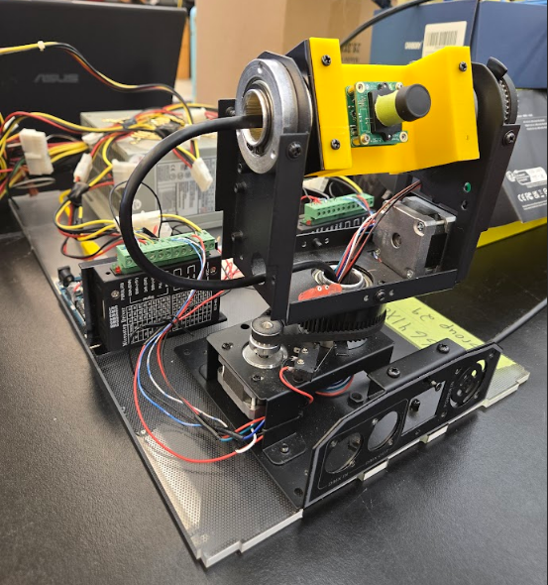

Figure 1: Final design of the Advanced Drone Tracking Camera System.

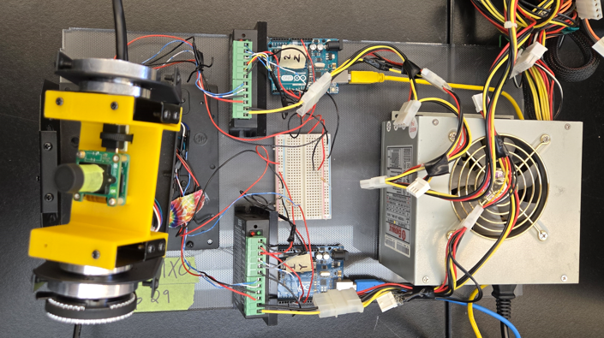Figure 2: Top-down view of the final system.

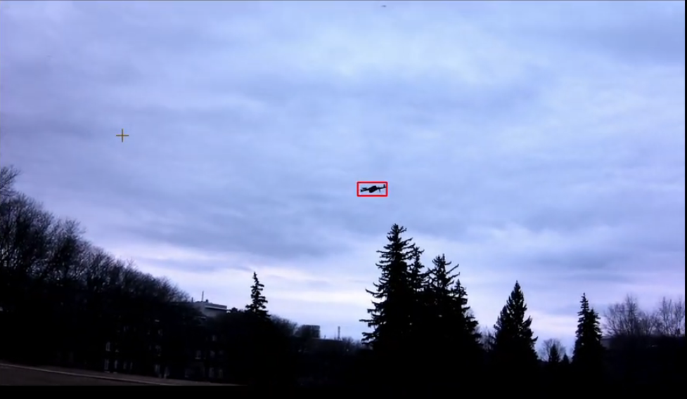Figure 3: Resulting frame from the tracking systems display feed.

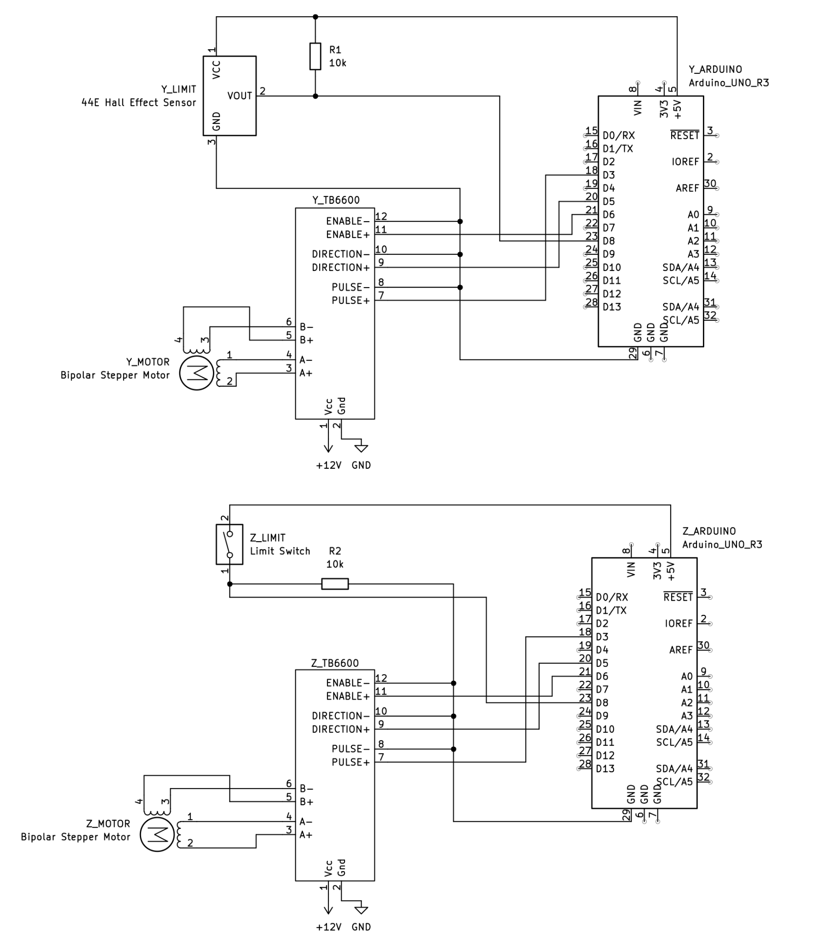

Figure 4: Schematic diagram of the Arduino Stepper Motor system.

Table 4: Bill of materials of the final design.
Part | Description | Qty | Unit Cost (CAD) | Cost (CAD)
Microcontroller | Arduino Uno | 2 | $37.99 | $75.98
Camera | Econ Systems See3CAM_24CUG | 1 | $260.61 | $260.61
Servo Motors and Frame | LED Moving Head Spotlight | 1 | $101.99 | $101.99
Power Supply | ENERMAX Whisper EG465P-VE(FC) 460 W ATX 12V Ver1.2 Power Supply | 1 | $74.00 | $74.00
Mounting Hardware | 3D Printed Hardware for Mounting Camera to Frame | 1 | $30.00 | $30.00
Servo Driver Board | TB6600 Stepper Motor Controller | 2 | $18.00 | $36.00
Various Lenses | 6mm M12 and 4.8mm N12 lenses | 2 | $27.62 | $55.24
Additional Costs | Wires, connectors, and miscellaneous electronic components | N/A | N/A | $20
Total Cost: |  |  |  | $653.82
The estimated total cost for implementing the drone tracking system prototype is approximately $653.82. This cost primarily covers the purchase of essential components such as the Arduino Uno units, servo motors, the camera, and the power supply. Additional costs include wiring, connectors, and miscellaneous electronic components required for assembly and testing.
While some components may seem expensive at first glance, some parts were selected because they were offered for free use by the university's lab, while other parts were selected because they were already in possession. For instance, the high-wattage power supply was already on hand, making it convenient to use for the project, even though it is overqualified for the current needs of the system. This provided a reliable power source without incurring extra costs. Similarly, the use of two stepper motor controllers was chosen to ensure precise control and flexibility in the system’s movement capabilities, even though a single controller could suffice for the current prototype. Although some components may appear overqualified or expensive, they were carefully chosen to meet the system’s requirements for precise tracking and image processing. In the future, costs may decrease with bulk purchases or alternative components, but for prototyping, these costs are justified to ensure a reliable and functional system.
The estimated cost of $653.82. The real-time drone tracking system is driven by key components such as the Arduino Uno units, camera, servo motors, and the 400W power supply, all essential for precise tracking and image processing. Additionally, there are costs associated with the 3D printed mounting hardware, wiring, and connectors, which are necessary for assembly and prototyping. The inclusion of a low-cost drone facilitates testing and validation of the tracking system. Although some components may seem expensive, they are critical for achieving the desired performance, and future savings may come from bulk purchases or alternative components, though for prototyping, these costs are justified for a reliable and functional system.
The work plan for the real-time drone tracking system project is structured into four main phases: Design, Prototyping, Testing and Calibration, and Optimization and Finalization.
- Design Phase focuses on finalizing the system layout and selecting key components, followed by the 3D printing of mounting hardware.
Prototyping Phase involves assembling the hardware components, setting up Arduino Uno units for image processing, and integrating servo control for the gimbal system.
- Testing and Calibration Phase is dedicated to integrating YOLOv8 with the Arduino Uno and camera, followed by calibrating the gimbal system to ensure precise tracking.
- Optimization and Finalization Phase involves optimizing the tracking algorithm and finalizing the system setup through extensive testing for reliability and robustness.
The project is organized with clear milestones and critical tasks, including integration of key technologies like YOLOv8, gimbal control, and real-time image processing. Risks such as hardware integration challenges and performance optimization delays are identified, with mitigation strategies in place.
For a detailed breakdown of each phase, associated milestones, critical tasks, and risk management strategies, please refer to the Project Management Appendix.

3. Design Defense

Function
The design demonstrates a clear understanding of the client's and users' needs, supported by thorough research and user feedback. User-centered design principles were applied to ensure that the system addresses specific challenges in real-time drone tracking, such as minimizing latency and maximizing accuracy in dynamic environments. Evidence from preliminary testing indicates that the tracking system outperforms previous models by offering more stable tracking and improved response times under various environmental conditions. Additionally, the design incorporates user preferences for intuitive controls and seamless integration with existing drone technologies, further ensuring that the solution meets practical user needs. The technical basis for these claims is grounded in performance metrics derived from simulations and real-world tests conducted with multiple drone models.

Safety
Our system was designed with safety as a fundamental consideration to ensure operational reliability and security. The stationary mounting minimizes mechanical stress and eliminates collision risks associated with autonomous tracker drones operating in airspace. To prevent malfunctions, servo motors are programmed with controlled speed adjustments, avoiding sudden jerks that could result in missing tracking data. The system also complies with relevant aviation regulations, with real-world simulations validating its safety performance. All claims are substantiated by test results that confirm the system's reliability under various conditions.

Economic
The economic feasibility of the design has been thoroughly analyzed, with evidence supporting its cost-effectiveness. A detailed budget was created to assess the costs of materials, components, and manufacturing processes. The system has been optimized to minimize production and operational costs while maximizing functionality, such as utilizing off-the-shelf components where feasible without compromising on quality. A cost-benefit analysis demonstrates that the design is economically viable, with an expected return on investment driven by its efficiency in tracking performance and integration into existing drone platforms. Additionally, scalability options were explored to further reduce costs in larger production runs, making the system accessible to a broader range of users. All claims are supported by a comprehensive breakdown of costs and projected financial outcomes.

Environmental Impact
The environmental impact of our system was carefully considered. The stationary nature of the tracking unit reduces the risk of environmental disruption, as it does not require the movement of drones or other components that could cause disturbances to wildlife or ecosystems. Furthermore, the system’s energy efficiency, enabled by its low-power servo motors and optimized design, helps reduce overall energy consumption. As a result, the system contributes to sustainable practices by minimizing its environmental footprint, particularly in fields where energy-efficient solutions are critical, such as in agriculture and environmental monitoring.

Social Impact
Our real-time drone tracking system offers several social benefits, including enhanced safety and improved efficiency in industries such as surveillance, search and rescue, and agriculture. By providing accurate, real-time tracking, the system enables timely responses to critical situations, contributing to better outcomes in emergency scenarios. Additionally, the design’s ease of integration into existing infrastructure ensures it can be adopted by a wide range of users, from hobbyists to professionals, making advanced drone tracking accessible to a broader audience. This widespread availability has the potential to enhance public safety, promote innovation, and support the development of new applications that benefit society.

4. Risks and Uncertainties

Assumptions
The real-time drone tracking system is based on several key assumptions that may introduce uncertainty into its operation. It assumes that the system will function optimally in a controlled environment with minimal interference from external factors such as severe weather conditions or strong electromagnetic interference. Additionally, it is assumed that the tracking system will maintain a stable communication link with the drone within its specified operational range. Furthermore, the system assumes that users will have the necessary technical expertise to set up and calibrate the system effectively. If these assumptions do not hold true, the system’s performance could be impacted, resulting in tracking errors or operational failures.

Limitations
While the system offers robust functionality, it is not without its limitations. The tracking accuracy can be compromised under adverse environmental conditions, such as strong winds or low-light settings, which may affect the object detection algorithm's performance. Additionally, the reliance on servo motors for mechanical adjustments limits the system's speed and precision in highly dynamic environments. The current system also has a high hardware footprint, which may limit its scalability or adaptability to different types of drones or environments. Furthermore, the power supply is reliant on external sources, making the system vulnerable to power outages or fluctuations that could disrupt tracking operations.

Sources of Error
Several sources of error and uncertainty have been identified that could negatively impact the system’s performance. Calibration errors are a major concern, as improper alignment of the tracking components could lead to inaccurate data and tracking failures. The object detection algorithm might also experience difficulty distinguishing between the drone and background objects in cluttered or visually complex environments, resulting in false positives or missed detections. Mechanical errors, such as malfunctions in the servo motors or power supply issues, also pose a risk to system reliability. Furthermore, environmental factors like electromagnetic interference could disrupt communication signals or sensor performance, reducing the system's accuracy and reliability in certain settings.

Potential Risks
The primary risks associated with the design solution come from its vulnerability to environmental factors, hardware malfunctions, and limitations in system calibration. Tracking inaccuracies, particularly under adverse weather conditions or in areas with high electromagnetic interference, pose significant risks to the system’s reliability. Additionally, signal loss or interruptions in communication between the system and the drone could result in the failure of tracking operations. The mechanical limitations of the servo motors and the power supply could lead to system downtime or inaccuracies in positioning. These risks highlight the need for ongoing testing and optimization to ensure the system can function in a wider range of conditions and with minimal errors.

Opportunities for Improvement
To improve the design and reduce risk, several opportunities exist to enhance its functionality and reduce its footprint. First, reducing the overall hardware footprint would make the system more portable and adaptable to a wider range of use cases. This could be achieved by utilizing more compact and integrated components, which would also lower power consumption and increase efficiency. Additionally, incorporating an alarm or notification mechanism would improve the system's response to critical failures, such as loss of signal or mechanical malfunctions, providing users with immediate alerts to prevent accidents or delays. This functionality could be added through software integration with a mobile app or web-based interface, allowing real-time monitoring of the system’s status. Another opportunity is to incorporate a more advanced object detection algorithm, such as a deep learning-based model, to improve tracking accuracy and robustness in cluttered or dynamic environments. Finally, adding redundancy to the communication and power systems would increase the system’s reliability, ensuring that it remains operational even in the event of a failure in one of the core components.

5. Conclusion and Recommendations
The real-time drone tracking system utilizes a 360-degree rotating camera mounted on a gimbal, with the camera's orientation controlled by two servo motors, powered by a 460W power supply. The system relies on Arduino Unos to process the video feed from the camera in real time, using YOLOv8-based object detection to detect the drone and automatically adjust the camera’s position to maintain focus on the drone’s movement. The modular design allows for easy scalability, with the system easily integrated into existing setups. It has been designed to meet safety, regulatory, and privacy standards, ensuring drones are tracked responsibly and effectively in dynamic and unpredictable environments. The use of a breadboard during prototyping allows for iterative testing and modification, ensuring the system’s adaptability and flexibility during development.
For future work, the system could be made more consumer-friendly by reducing its physical footprint and improving its cost efficiency, making it accessible to a wider range of users, including those with limited technical knowledge. The setup process could be simplified for ease of use by non-technical individuals, offering intuitive installation guides or plug-and-play components. Additionally, integrating new functionalities like a notification system to alert clients when drones are in proximity would enhance security by providing real-time alarms. Improvements in power efficiency, environmental adaptability, and faster response times for tracking fast-moving drones would further enhance the system's performance. Expanding its compatibility with various drone models and enhancing its ability to operate in challenging weather conditions could broaden its applications.

5. References

[1]“6 Barriers to Drone Adoption in Infrastructure & Transportation and How to Overcome Them,” www.commercialuavnews.com. https://www.commercialuavnews.com/infrastructure/6-challenges-with-drone-adoption-in-infrastructure-transportation-and-how-to-overcome-them

[2] “Top Energy Sources Powering Drones,” Clearspot.ai, Sep. 03, 2024. https://clearspot.ai/top-energy-sources-powering-drones/ (accessed Oct. 28, 2024).

[3 ] M. McNabb, “Business Insider’s Latest Drone Industry Analysis,” DRONELIFE, Jul. 13, 2017. https://dronelife.com/2017/07/13/business-insiders-latest-drone-industry-analysis/

[4] “Discover the Perks and Challenges of Having GPS Drones,” ZenaDrone Homepage, Apr. 03, 2023. https://www.zenadrone.com/discover-the-perks-and-challenges-of-having-gps-drones/

[5] Canada, “Canada Gazette – Regulations Amending the Canadian Aviation Regulations (Unmanned Aircraft Systems),” Gazette.gc.ca, 2017. https://www.gazette.gc.ca/rp-pr/p1/2017/2017-07-15/html/reg2-eng.html (accessed Oct. 28, 2024).

[6]“Computer Engineering Technology,” ZipRecruiter, 2024. https://www.ziprecruiter.com/Salaries/Computer-Engineering-Technology-Salary--in-Ontario (accessed Oct. 31, 2024).

[7] Ayushkumawat, “GitHub - Ayushkumawat/Advanced-Aerial-Drone-Detection-System” GitHub, 2023. https://github.com/Ayushkumawat/Advanced-Aerial-Drone-Detection-System (accessed Feb. 14, 2025).
‌

6. Appendices

Appendix A - Response to Feedback
Clear Introduction to Criteria and Constraints
- Added a clear explanation of how the criteria and constraints were identified, based on problem definition and stakeholder discussions.
- Built on the importance of measurable, black-and-white criteria to reduce ambiguity.
Use of Measurable Criteria and Constraints
- Revised criteria to include specific, measurable values (e.g., tracking accuracy within ±100 meters, updates faster than 150ms) for clear evaluation.
Selection of the Best Alternative Using Decision-Making
- Adopted a weighted scoring method to rank alternatives.
- Conducted sensitivity analysis to evaluate how changes in criteria weights affected the decision.
- Explained the decision-making process and how each alternative was ranked based on the weighted criteria.
Clarification on the Weighting of Criteria
- Described how different criteria weights were assigned, with justification for the importance of each criterion.

Appendix B - Decision Matrices and Sensitivity Analysis

Table 5: Sensitivity Analysis. Criteria range: 5-Excellent 4-Very Good 3-Good 2-Satisfactory 1-Poor

Criteria | Criteria Weight  (%) | Stationary Video Camera |  | Tracker Drone |  | Stationary camera with 360 degree view
 |  | Rating | Weighted Rating | Rating | Weighted Rating | Rating | Weighted Rating
Affordability | 5 | 1 | 0.05 | 3 | 0.15 | 4 | 0.2
Power Efficiency | 10 | 4 | 0.4 | 1 | 0.10 | 5 | 0.5
Ease of Installation | 5 | 5 | 0.25 | 5 | 0.25 | 5 | 0.25
HD Visuals | 35 | 4 | 1.4 | 5 | 1.75 | 5 | 1.75
Access remotely | 20 | 5 | 1 | 5 | 1 | 5 | 1
Tracking Capabilities | 25 | 2 | 0.5 | 5 | 1.25 | 5 | 1.25
Total Score |  |  | 3.6 |  | 4.5 |  | 4.95

Table 6: Decision Matrix. Criteria range: 5-Excellent 4-Very Good 3-Good 2-Satisfactory 1-Poor
Criteria | Criteria Weight  (%) | Stationary Video Camera |  | Tracker Drone |  | Stationary camera with 360 degree view
 |  | Rating | Weighted Rating | Rating | Weighted Rating | Rating | Weighted Rating
Affordability | 10 | 1 | 0.1 | 3 | 0.3 | 4 | 0.4
Power Efficiency | 10 | 4 | 0.4 | 1 | 0.1 | 5 | 0.5
Ease of Installation | 10 | 5 | 0.5 | 5 | 0.5 | 5 | 0.5
HD Visuals | 30 | 4 | 1.2 | 5 | 1.5 | 5 | 1.5
Access remotely | 20 | 5 | 1 | 5 | 1 | 5 | 1
Tracking Capabilities | 20 | 2 | 0.4 | 5 | 1 | 5 | 1
Total Score |  |  | 3.6 |  | 4.4 |  | 4.9

Appendix C - Calculations/Modeling

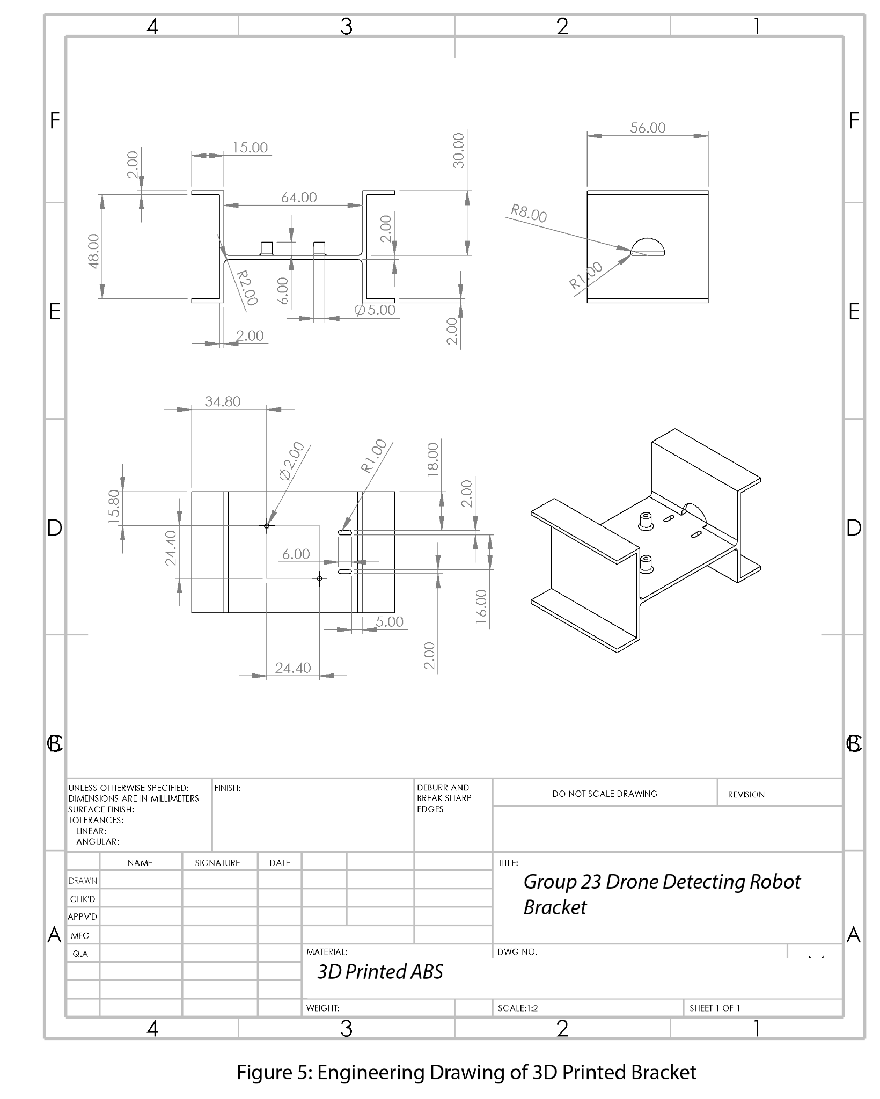
Figure 5: SOLIDWORKS model of the camera bracket.

Drone Bounding Box Center Calculation

To accurately track a drone's position within the video frame, the center of its bounding box must be determined. This is essential for calculating the displacement (delta) from the frame's center, which is then used to control the servo motor's movement.

Below is the Python function used to compute the drone's center coordinates:

def get_drone_center(x1, y1, x2, y2):
# Get the center coordinates of a bounding box
center_x = int((x1 + x2) / 2)
center_y = int((y1 + y2) / 2)
return center_x, center_y

Parameters:
- x1, y1: Coordinates of the top-left corner of the bounding box.
- x2, y2: Coordinates of the bottom-right corner of the bounding box.
The function computes the midpoint between the bounding box's corners to find the center of the detected object (drone). This center point (center_x, center_y) is used to determine the drone's position relative to the frame center. This calculation is a key component in the tracking algorithm. By determining the drone's center, the system can compare it against the frame’s center to calculate delta for both horizontal and vertical axes. Use this delta in the movement calculation model to determine servo adjustments.
Servo Motor Movement Calculation

To optimize the camera tracking system's responsiveness to drone movement, a non-linear step adjustment model was implemented. This ensures small corrections when the drone is near the center of the frame and larger, quicker adjustments when the drone moves further from center—improving both precision and responsiveness.
The calculation is based on the drone’s displacement (delta) from the center of the video frame.

Here's the Python function used in the simulation and real-time control logic:

def calculate_movement(delta, frame_size, max_steps, min_steps):
normalized_dist = abs(delta) / (frame_size / 2)
scaled_value = normalized_dist ** 2
steps = int(min_steps + (max_steps - min_steps) * scaled_value)
return min(steps, max_steps)

Parameters:
- delta: Distance (in pixels) between the center of the frame and the detected drone’s position.
- frame_size: Width or height of the frame depending on the axis of motion.
- max_steps: Maximum allowable steps the servo can take in one update cycle.
- min_steps: Minimum steps (to prevent system lag when the drone is close to center).
The movement calculation model employs a dynamic, non-linear approach to optimize servo responsiveness during tracking. First, the drone’s displacement from the frame center is normalized, converting its position into a value between 0 and 1. This normalized distance is then squared to produce a non-linear (quadratic) scaling, which enhances sensitivity to larger movements while dampening minor ones. The scaled value is used in a linear interpolation between predefined minimum and maximum step sizes, ensuring that servo adjustments are proportional to the drone's position. Finally, the calculated steps are clamped to a maximum threshold to prevent overcorrection. This method reduces jitter when the drone is near the frame center and increases servo speed when the drone moves rapidly across the frame, resulting in smoother and more efficient tracking performance.

Appendix D - Project Management - Time Spent and Cost of Design
Phase 1: Design Phase (Weeks 1-3)
Key Activities:
- Finalize System Layout and Component Selection:
  - Identify and select all necessary components (e.g., Arduino Uno units, camera, servo motors, power supply).
  - Confirm compatibility between components.
  - Establish technical specifications (e.g., camera resolution, servo range, power requirements).
- 3D Printing of Mounting Hardware:
  - Design and finalize CAD models for mounting hardware.
  - Print initial prototypes for camera and servo mounts.
  - Perform iterative design modifications based on fitment and stability tests.
Milestones:
- Finalized system design with component list.
- Completed CAD models and 3D-printed mounts.
Critical Tasks:
- Verifying component compatibility and availability.
- Addressing potential issues in the mounting design (e.g., weight distribution or stability).
Risk Management:
- Risk: Delays in component availability or shipping.
  - Mitigation: Confirm availability of components in advance and order as early as possible.
- Risk: Issues with the accuracy of 3D printed hardware.
  - Mitigation: Conduct thorough testing of initial prints and refine designs as needed.
Phase 2: Prototyping Phase (Weeks 4-6)
Key Activities:
- Assemble Hardware:
  - Connect and integrate all components (camera, servo motors, power supply).
  - Wire the system on a breadboard for easy adjustments.
- Set Up Arduino Uno Units:
  - Install necessary software and dependencies on the Arduino Uno units.
  - Set up an image processing system using YOLOv8 and configure servo motor control.
Milestones:
- Assembled hardware prototype with all components connected.
- Arduino Uno units configured for initial testing.
Critical Tasks:
- Ensuring proper wiring and connections for all components.
- Installing and configuring YOLOv8 on Arduino Uno units.
Risk Management:
- Risk: Connectivity issues between components (e.g., servo motors not responding).
  - Mitigation: Double-check wiring and communication protocols before proceeding with integration.
- Risk: Software setup challenges (e.g., issues with YOLOv8 performance).
  - Mitigation: Allocate extra time for troubleshooting and ensure Arduino Uno meets system requirements.
Phase 3: Testing and Calibration Phase (Weeks 7-8)
Key Activities:
- Integrate YOLOv8 with Arduino Uno and Camera:
  - Test YOLOv8's object detection capabilities with the camera feed.
  - Verify that the drone is detected reliably in various lighting conditions.
- Calibrate the Gimbal System:
  - Fine-tune servo motor controls for smooth and precise camera tracking.
  - Adjust the gimbal system for proper range and responsiveness.
Milestones:
- Successful integration of YOLOv8 and camera with Arduino Uno.
- Gimbal system calibrated for accurate drone tracking.
Critical Tasks:
- Test the detection range and accuracy of YOLOv8.
- Ensure servo motors provide precise control and movement with minimal lag.
Risk Management:
- Risk: YOLOv8 may not detect the drone accurately in all environments.
  - Mitigation: Test and fine-tune the object detection algorithm for varying lighting and drone movement conditions.
- Risk: Servo motors may not offer the required precision for tracking.
  - Mitigation: Adjust servo settings and experiment with different motor types if necessary.
Phase 4: Optimization and Finalization Phase (Weeks 9-12)
Key Activities:
- Optimize Tracking Algorithm:
  - Enhance the algorithm for better response time and tracking accuracy.
  - Implement real-time updates and minimize any lag in the system.
- Finalize System Setup:
  - Conduct comprehensive testing under real-world conditions (e.g., varied environments and movement speeds).
  - Make final adjustments to the system setup, including hardware and software.
- Extensive Testing for Reliability and Robustness:
  - Stress tests the entire system for performance and reliability over extended periods.
  - Ensure that the system meets the required specifications and operates without failure.
Milestones:
- Optimized tracking algorithm with enhanced accuracy and responsiveness.
- Finalized, fully operational system with no major issues.
Critical Tasks:
- Fine-tuning the tracking algorithm to eliminate lag.
- Extensive testing to ensure system stability and performance under various conditions.
Risk Management:
- Risk: Algorithm optimization may take longer than anticipated.
  - Mitigation: Allocate additional time for performance tuning and address bottlenecks.
- Risk: Potential system instability under real-world testing.
  - Mitigation: Conduct incremental tests and address minor issues as they arise.

Appendix E - Additional Information
The following code is the most optimized version developed for the object detection algorithm that uses YOLOv8.

import cv2
import torch
import numpy as np
from ultralytics import YOLO

# device = 'cuda' # Uncomment to use GPU
device = 'cpu'

print(f"Using device: {device}")

# Load YOLOv8 model
model = YOLO('C:/VSCode/DroneDetection/Advanced-Aerial-Drone-Detection-System/best.pt').to(device)

# Set video source (webcam or video file)
cap = cv2.VideoCapture(1, cv2.CAP_DSHOW)

# Define the classes you want to detect
classes = ['Drone']

# Create a window for display
cv2.namedWindow('frame')

while True:
# Capture frame-by-frame
ret, frame = cap.read()
if not ret:
break

img = frame # YOLOv8 can handle BGR directly

# Run inference
results = model(img)

# Process the results and draw bounding boxes on the frame
for result in results[0].boxes.data: # Access detected objects
x1, y1, x2, y2, conf, cls = result.tolist()
if conf > 0.5 and classes[int(cls)] in classes:
# Draw bounding box
cv2.rectangle(frame, (int(x1), int(y1)), (int(x2), int(y2)), (0, 0, 255), 2)

# Display the resulting frame
cv2.imshow('frame', frame)

# Wait for key press to exit
if cv2.waitKey(1) == ord('q'):
break

# Release resources
cap.release()
cv2.destroyAllWindows()

The following code utilizes the Telemetrix library to move the servo motors of the hardware. This version of the code moves the servo motors based on the user's mouse cursor location on their display.

import sys
import time
import cv2
import numpy as np
from ultralytics import YOLO
from telemetrix import telemetrix_high_speed
from pynput.mouse import Controller

MAX_MOTOR_Z = -5350 #DO NOT CHANGE
MAX_MOTOR_Y = 1490 #DO NOT CHANGE EITHER

MAX_MOUSE_Z = 1920
MAX_MOUSE_Y = 1080 #Your monitors vertical resosleaust

DISABLE_Y = 6
DIR_Y = 5
PULSE_Y = 3
LIMIT_Y = 8

limit_Y_state = 0
homing_Y_initiated = 0
homed_Y = 0

DISABLE_Z = 6
DIR_Z = 5
PULSE_Z = 3
LIMIT_Z = 8

limit_Z_state = 0
homing_Z_initiated = 0
homed_Z = 0

board_Y = telemetrix_high_speed.Telemetrix(arduino_instance_id=1)
board_Z = telemetrix_high_speed.Telemetrix(arduino_instance_id=2)

mouse = Controller()

# Load YOLOv8 model
model = YOLO('C:/VSCode/DroneDetection/Advanced-Aerial-Drone-Detection-System/best.pt')

# Define the classes you want to detect
classes = ['Drone']

cap = cv2.VideoCapture(0,cv2.CAP_DSHOW)

def Limit_Y_Callback(data):
global limit_Y_state
global false_start_Y
global homed_Y
limit_Y_state = (data[2])
if limit_Y_state == 0:
board_Y.stepper_stop(motor_Y)
if limit_Y_state == 0 and homing_Y_initiated == 1:
homed_Y = 1
board_Y.stepper_set_current_position(motor_Y, 0)
board_Y.stepper_set_max_speed(motor_Y,5000)
time.sleep(.01)
board_Y.stepper_set_acceleration(motor_Y, 10000)
time.sleep(.01)
#pass

def Limit_Z_Callback(data):
global limit_Z_state
global false_start_Z
global homed_Z
limit_Z_state = data[2]
if limit_Z_state == 1:
board_Z.stepper_stop(motor_Z)
if limit_Z_state == 1 and homing_Z_initiated == 1:
homed_Z = 1
board_Z.stepper_set_current_position(motor_Z, 0)
board_Z.stepper_set_max_speed(motor_Z,4000)
time.sleep(.01)
board_Z.stepper_set_acceleration(motor_Z, 8000)
time.sleep(.01)

def motor_Y_complete_callback(data):
pass

def motor_Z_complete_callback(data):
pass

def motor_Z_current_position_callback(data):
print(f'motor_Z pos: {data[2]}\n')

def motor_Y_current_position_callback(data):
print(f'motor_Y pos: {data[2]}\n')

def false_start_Z_callback(data):
#run opposite direction from whatever
board_Z.stepper_move(motor_Z,0)
time.sleep(.01)
board_Z.stepper_set_speed(motor_Z,100)
time.sleep(.01)
board_Z.stepper_run_speed(motor_Z)

def false_start_Y_callback(data):
#run opposite direction from whatever
board_Y.stepper_move(motor_Y,0)
time.sleep(.01)
board_Y.stepper_set_speed(motor_Y,-100)
time.sleep(.01)
board_Y.stepper_run_speed(motor_Y)

def get_drone_center(x1, y1, x2, y2):
#Get the center coordinates of a bounding box
center_x = int((x1 + x2) / 2)
center_y = int((y1 + y2) / 2)
return center_x, center_y

board_Y.set_pin_mode_digital_input(LIMIT_Y, Limit_Y_Callback)
time.sleep(.01)

board_Z.set_pin_mode_digital_input(LIMIT_Z, Limit_Z_Callback)
time.sleep(.01)

motor_Y = board_Y.set_pin_mode_stepper(interface = 1, pin1 = PULSE_Y, pin2 = DIR_Y)
time.sleep(.01)

motor_Z = board_Z.set_pin_mode_stepper(interface = 1, pin1 = PULSE_Z, pin2 = DIR_Z)
time.sleep(.01)

board_Y.set_pin_mode_digital_output(DISABLE_Y)
time.sleep(.01)

board_Z.set_pin_mode_digital_output(DISABLE_Z)
time.sleep(.01)

board_Y.stepper_set_max_speed(motor_Y,4000)
time.sleep(.01)
board_Z.stepper_set_max_speed(motor_Z,4000)
time.sleep(.01)

board_Y.stepper_set_acceleration(motor_Y, 1000)
time.sleep(.01)
board_Z.stepper_set_acceleration(motor_Z, 1000)
time.sleep(.01)

if limit_Y_state == 0:
board_Y.stepper_set_acceleration(motor_Y, 10000)
board_Y.stepper_move(motor_Y,150)
board_Y.stepper_run_speed_to_position(motor_Y, false_start_Y_callback)
homing_Y_initiated = 1
else:
board_Y.stepper_move(motor_Y,0)
time.sleep(.01)
board_Y.stepper_set_speed(motor_Y,-100)
time.sleep(.01)
board_Y.stepper_run_speed(motor_Y)
homing_Y_initiated = 1

if limit_Z_state == 1:
board_Z.stepper_set_acceleration(motor_Z, 10000)
board_Z.stepper_move(motor_Z,-150)
board_Z.stepper_run_speed_to_position(motor_Z, false_start_Z_callback)
homing_Z_initiated = 1
else:
board_Z.stepper_move(motor_Z,0)
time.sleep(.01)
board_Z.stepper_set_speed(motor_Z,100)
time.sleep(.01)
board_Z.stepper_run_speed(motor_Z)
homing_Z_initiated = 1

try:
while homed_Z == 0 or homed_Y == 0:
if homed_Z == 0 and homed_Y == 1:
print("\rHoming Z... ", end='')
sys.stdout.flush()
elif homed_Y == 0 and homed_Z ==1:
print("\rHoming Y... ", end='')
sys.stdout.flush()
else:
print("\rHoming Z and Y...", end='')
sys.stdout.flush()
print("shit happeng")

time.sleep(1)

print("\nProgram Begin")

# Create a window for display
cv2.namedWindow('frame')

while True:
ret, frame = cap.read()
if not ret:
break

# Run inference
results = model(frame)

# Process the results and draw bounding boxes on the frame
for result in results[0].boxes.data: # Access detected objects
x1, y1, x2, y2, conf, cls = result.tolist()
if conf > 0.5 and classes[int(cls)] in classes:
# Draw bounding box
cv2.rectangle(frame, (int(x1), int(y1)), (int(x2), int(y2)), (0, 0, 255), 2)

# Display the resulting frame
cv2.imshow('frame', frame)

Z_destination = int(np.interp(mouse.position[0], [0,MAX_MOUSE_Z], [MAX_MOTOR_Z,0])) # maps the position of the mouse on screen to the range of the motor
Y_destination = int(np.interp(mouse.position[1], [0,MAX_MOUSE_Y], [0,MAX_MOTOR_Y])) # the z motor has range (0, -5350) and y has range (0, +1490).

# Move the motors based on the mouse position
board_Z.stepper_move_to(motor_Z, Z_destination)
board_Y.stepper_move_to(motor_Y, Y_destination)

# Execute motor movements
board_Z.stepper_run(motor_Z, motor_Z_complete_callback)
board_Y.stepper_run(motor_Y, motor_Y_complete_callback)

# Wait for a key press and check if it's 'q'
key = cv2.waitKey(1) & 0xFF
if key == ord('q'): # If 'q' is pressed, exit the loop
break

time.sleep(0.008) # Approx 120 FPS.

except KeyboardInterrupt:
pass
finally:
# Clean up and shut down everything properly
board_Z.stepper_stop(motor_Z)
board_Y.stepper_stop(motor_Y)
board_Z.digital_write(DISABLE_Z, 1)
board_Y.digital_write(DISABLE_Y, 1)
board_Z.shutdown()
board_Y.shutdown()
cap.release()
cv2.destroyAllWindows()
sys.exit(0)

The following code is the final product code that combines the object detection algorithm with the hardware interface.

import sys
import time
import cv2
import numpy as np
from ultralytics import YOLO
from telemetrix import telemetrix_high_speed

# Motor physical limits (DO NOT CHANGE)
MAX_MOTOR_Z = -5350 # Maximum steps for Z axis (left limit)
MAX_MOTOR_Y = 1490 # Maximum steps for Y axis (up limit)

# Motor pins
DISABLE_Y = 6
DIR_Y = 5
PULSE_Y = 3
LIMIT_Y = 8

DISABLE_Z = 6
DIR_Z = 5
PULSE_Z = 3
LIMIT_Z = 8

# Motor states
limit_Y_state = 0
homing_Y_initiated = 0
homed_Y = 0

limit_Z_state = 0
homing_Z_initiated = 0
homed_Z = 0

# Initialize motor boards
board_Y = telemetrix_high_speed.Telemetrix(arduino_instance_id=1)
board_Z = telemetrix_high_speed.Telemetrix(arduino_instance_id=2)

# Load YOLOv8 model
model = YOLO('C:/VSCode/DroneDetection/Advanced-Aerial-Drone-Detection-System/best_test.pt')
classes = ['Drone']

# Video capture
cap = cv2.VideoCapture(0, cv2.CAP_DSHOW)

# Tracking and search parameters
search_mode = True
search_direction_z = 1 # 1 for right, -1 for left
search_direction_y = 1 # 1 for up, -1 for down
last_detection_time = 0
SEARCH_TIMEOUT = 2 # seconds before returning to search mode

# Movement parameters
MAX_Z_STEPS = 160 # Maximum steps for Z axis per movement
MAX_Y_STEPS = 80 # Maximum steps for Y axis per movement
MIN_Z_STEPS = 1 # Minimum steps for Z axis
MIN_Y_STEPS = 1 # Minimum steps for Y axis
DEAD_ZONE_PERCENT = 0.10 # 10% dead zone

# Boundary tracking variables
current_z_pos = 0 # Tracks approximate Z position (steps from home)
current_y_pos = 0 # Tracks approximate Y position (steps from home)
SAFETY_MARGIN_Z = 100 # Safety margin in steps for Z axis
SAFETY_MARGIN_Y = 50 # Safety margin in steps for Y axis

def Limit_Y_Callback(data):
global limit_Y_state, homed_Y, homing_Y_initiated
limit_Y_state = data[2]
if limit_Y_state == 0:
board_Y.stepper_stop(motor_Y)
if limit_Y_state == 0 and homing_Y_initiated == 1:
homed_Y = 1
board_Y.stepper_set_current_position(motor_Y, 0)
board_Y.stepper_set_max_speed(motor_Y, 5000)
time.sleep(0.01)
board_Y.stepper_set_acceleration(motor_Y, 10000)
time.sleep(0.01)

def Limit_Z_Callback(data):
global limit_Z_state, homed_Z, homing_Z_initiated
limit_Z_state = data[2]
if limit_Z_state == 1:
board_Z.stepper_stop(motor_Z)
if limit_Z_state == 1 and homing_Z_initiated == 1:
homed_Z = 1
board_Z.stepper_set_current_position(motor_Z, 0)
board_Z.stepper_set_max_speed(motor_Z, 4000)
time.sleep(0.01)
board_Z.stepper_set_acceleration(motor_Z, 8000)
time.sleep(0.01)

def motor_Y_complete_callback(data):
pass

def motor_Z_complete_callback(data):
pass

def motor_Z_current_position_callback(data):
print(f'motor_Z pos: {data[2]}\n')

def motor_Y_current_position_callback(data):
print(f'motor_Y pos: {data[2]}\n')

def false_start_Z_callback(data):
board_Z.stepper_move(motor_Z, 0)
time.sleep(0.01)
board_Z.stepper_set_speed(motor_Z, 100)
time.sleep(0.01)
board_Z.stepper_run_speed(motor_Z)

def false_start_Y_callback(data):
board_Y.stepper_move(motor_Y, 0)
time.sleep(0.01)
board_Y.stepper_set_speed(motor_Y, -100)
time.sleep(0.01)
board_Y.stepper_run_speed(motor_Y)

def get_drone_center(x1, y1, x2, y2):
return int((x1 + x2) / 2), int((y1 + y2) / 2)

def calculate_movement(delta, frame_size, max_steps, min_steps):
"""Calculate movement steps with non-linear response"""
normalized_dist = abs(delta) / (frame_size / 2)
scaled_value = normalized_dist ** 2
steps = int(min_steps + (max_steps - min_steps) * scaled_value)
return min(steps, max_steps)

def is_within_z_bounds(proposed_steps):
"""Check if proposed movement would stay within Z bounds"""
global current_z_pos
new_pos = current_z_pos + proposed_steps
return (MAX_MOTOR_Z + SAFETY_MARGIN_Z <= new_pos <= 0 - SAFETY_MARGIN_Z)

def is_within_y_bounds(proposed_steps):
"""Check if proposed movement would stay within Y bounds"""
global current_y_pos
new_pos = current_y_pos + proposed_steps
return (0 + SAFETY_MARGIN_Y <= new_pos <= MAX_MOTOR_Y/2 - SAFETY_MARGIN_Y)

def recover_from_z_limit():
"""Recover when approaching Z limit"""
global current_z_pos
recovery_steps = 500 # Fixed recovery amount
if current_z_pos <= MAX_MOTOR_Z + SAFETY_MARGIN_Z:
move_z(recovery_steps) # Too far left, move right
elif current_z_pos >= 0 - SAFETY_MARGIN_Z:
move_z(-recovery_steps) # Too far right, move left

def recover_from_y_limit():
"""Recover when approaching Y limit"""
global current_y_pos
recovery_steps = 250 # Fixed recovery amount
if current_y_pos <= 0 + SAFETY_MARGIN_Y:
move_y(recovery_steps) # Too far down, move up
elif current_y_pos >= MAX_MOTOR_Y/2 - SAFETY_MARGIN_Y:
move_y(-recovery_steps) # Too far up, move down

def move_z(steps):
"""Safe Z axis movement with boundary checking"""
global current_z_pos

if not is_within_z_bounds(steps):
print("Warning: Z movement would exceed limits!")
recover_from_z_limit()
return False

current_z_pos += steps
board_Z.stepper_move(motor_Z, steps)
board_Z.stepper_run(motor_Z, motor_Z_complete_callback)
return True

def move_y(steps):
"""Safe Y axis movement with boundary checking"""
global current_y_pos

if not is_within_y_bounds(steps):
print("Warning: Y movement would exceed limits!")
recover_from_y_limit()
return False

current_y_pos += steps
board_Y.stepper_move(motor_Y, steps)
board_Y.stepper_run(motor_Y, motor_Y_complete_callback)
return True

def execute_search_pattern():
"""Execute safe search pattern within motor limits"""
global current_z_pos, current_y_pos, search_direction_z, search_direction_y

# Check if we need to reverse direction due to approaching limits
if not is_within_z_bounds(search_direction_z * 5):
search_direction_z *= -1
if not is_within_y_bounds(search_direction_y * 2):
search_direction_y *= -1

# Configure movement parameters
search_speed_z = 1000 # steps/sec for Z axis
search_speed_y = 800 # steps/sec for Y axis

board_Z.stepper_set_max_speed(motor_Z, search_speed_z)
board_Y.stepper_set_max_speed(motor_Y, search_speed_y)

board_Z.stepper_set_acceleration(motor_Z, 5000)
board_Y.stepper_set_acceleration(motor_Y, 4000)

# Use safe movement functions
move_z(search_direction_z * 5)
move_y(search_direction_y * 2)

# Initialize motor pins and settings
board_Y.set_pin_mode_digital_input(LIMIT_Y, Limit_Y_Callback)
board_Z.set_pin_mode_digital_input(LIMIT_Z, Limit_Z_Callback)
time.sleep(0.01)

motor_Y = board_Y.set_pin_mode_stepper(interface=1, pin1=PULSE_Y, pin2=DIR_Y)
motor_Z = board_Z.set_pin_mode_stepper(interface=1, pin1=PULSE_Z, pin2=DIR_Z)
time.sleep(0.01)

board_Y.set_pin_mode_digital_output(DISABLE_Y)
board_Z.set_pin_mode_digital_output(DISABLE_Z)
time.sleep(0.01)

board_Y.stepper_set_max_speed(motor_Y, 4000)
board_Z.stepper_set_max_speed(motor_Z, 4000)
time.sleep(0.01)

board_Y.stepper_set_acceleration(motor_Y, 1000)
board_Z.stepper_set_acceleration(motor_Z, 1000)
time.sleep(0.01)

# Homing procedure
if limit_Y_state == 0:
board_Y.stepper_set_acceleration(motor_Y, 10000)
board_Y.stepper_move(motor_Y, 150)
board_Y.stepper_run_speed_to_position(motor_Y, false_start_Y_callback)
homing_Y_initiated = 1
else:
board_Y.stepper_move(motor_Y, 0)
time.sleep(0.01)
board_Y.stepper_set_speed(motor_Y, -100)
time.sleep(0.01)
board_Y.stepper_run_speed(motor_Y)
homing_Y_initiated = 1

if limit_Z_state == 1:
board_Z.stepper_set_acceleration(motor_Z, 10000)
board_Z.stepper_move(motor_Z, -150)
board_Z.stepper_run_speed_to_position(motor_Z, false_start_Z_callback)
homing_Z_initiated = 1
else:
board_Z.stepper_move(motor_Z, 0)
time.sleep(0.01)
board_Z.stepper_set_speed(motor_Z, 100)
time.sleep(0.01)
board_Z.stepper_run_speed(motor_Z)
homing_Z_initiated = 1

# Wait for homing to complete
try:
while homed_Y == 0 or homed_Z == 0:
if homed_Y == 0:
print("\rHoming Y... ", end='')
if homed_Z == 0:
print("\rHoming Z... ", end='')
sys.stdout.flush()
print("Homing complete")

time.sleep(1)
print("\nProgram Begin")
cv2.namedWindow('frame')

while True:
ret, frame = cap.read()
if not ret:
break

key = cv2.waitKey(1)
if key == ord('q'):
break

frame = cv2.flip(frame, -1)
screen_center_x = frame.shape[1] // 2
screen_center_y = frame.shape[0] // 2
dead_zone_x = int(screen_center_x * DEAD_ZONE_PERCENT)
dead_zone_y = int(screen_center_y * DEAD_ZONE_PERCENT)

# Run inference
results = model(frame)
drone_detected = False
closest_drone = None
min_distance = float('inf')

# Process detection results to find the closest drone to center
for result in results[0].boxes.data:
x1, y1, x2, y2, conf, cls = result.tolist()
if conf > 0.5 and classes[int(cls)] in classes:
drone_center_x, drone_center_y = get_drone_center(x1, y1, x2, y2)
distance_to_center = ((drone_center_x - screen_center_x)**2 +
(drone_center_y - screen_center_y)**2)**0.5

if distance_to_center < min_distance:
min_distance = distance_to_center
closest_drone = {
'x1': x1,
'y1': y1,
'x2': x2,
'y2': y2,
'center_x': drone_center_x,
'center_y': drone_center_y
}

# Tracking or search logic
if closest_drone is not None:
drone_detected = True
last_detection_time = time.time()
search_mode = False

# Draw rectangle around the closest drone
cv2.rectangle(frame,
(int(closest_drone['x1']), int(closest_drone['y1'])),
(int(closest_drone['x2']), int(closest_drone['y2'])),
(0, 0, 255), 2)

delta_x = closest_drone['center_x'] - screen_center_x
delta_y = closest_drone['center_y'] - screen_center_y

if abs(delta_x) > dead_zone_x or abs(delta_y) > dead_zone_y:
z_steps = calculate_movement(delta_x, frame.shape[1], MAX_Z_STEPS, MIN_Z_STEPS)
y_steps = calculate_movement(delta_y, frame.shape[0], MAX_Y_STEPS, MIN_Y_STEPS)

z_steps = -z_steps if delta_x < 0 else z_steps
y_steps = y_steps if delta_y < 0 else -y_steps

tracking_speed_z = 800
tracking_speed_y = 600

board_Z.stepper_set_max_speed(motor_Z, tracking_speed_z)
board_Y.stepper_set_max_speed(motor_Y, tracking_speed_y)

board_Z.stepper_set_acceleration(motor_Z, 4000)
board_Y.stepper_set_acceleration(motor_Y, 3000)

move_z(z_steps)
move_y(y_steps)

elif not drone_detected:
if time.time() - last_detection_time > SEARCH_TIMEOUT:
search_mode = True

if search_mode:
#execute_search_pattern() // Delete comment to enable search mode
pass

cv2.imshow('frame', frame)
time.sleep(0.008)

except KeyboardInterrupt:
pass
finally:
# Cleanup
board_Z.stepper_stop(motor_Z)
board_Y.stepper_stop(motor_Y)
board_Z.digital_write(DISABLE_Z, 1)
board_Y.digital_write(DISABLE_Y, 1)
board_Z.shutdown()
board_Y.shutdown()
cap.release()
cv2.destroyAllWindows()
sys.exit(0)

